***FARRAGUT MIDDLE SCHOOL ATHLETICS INFORMATION***

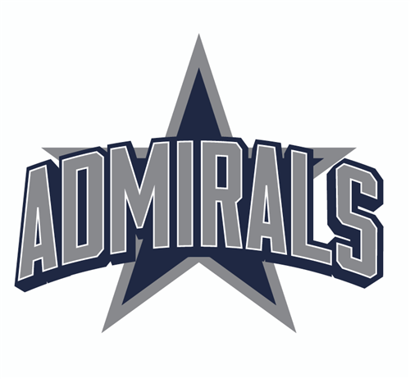

FMS Athletics Director: Mark Palmer [mark.palmer@knoxschools.org](mailto:mark.palmer@knoxschools.org)

FMS Boys Basketball Coach: Lynn Allen [lynn.allen@knoxschools.org](mailto:lynn.allen@knoxschools.org)

FMS Girls Basketball Coach: Devan McIntyre [devan.mcintyre@knoxschools.org](mailto:devan.mcintyre@knoxschools.org)

FMS Cheer Coach: Maysi Ellison [maysi.ellison@knoxschools.org](mailto:maysi.ellison@knoxschools.org)

FMS Boys Track Coach: Chris Cavalaris christopher.cavalaris@knoxschools.org

FMS Girls Track Coach: Sarah Archer sarah.archer@knoxschools.org